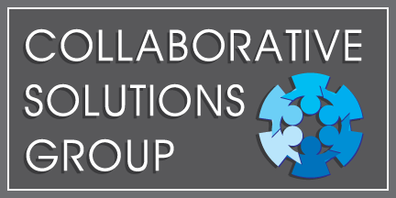

- DISC Broken Down -

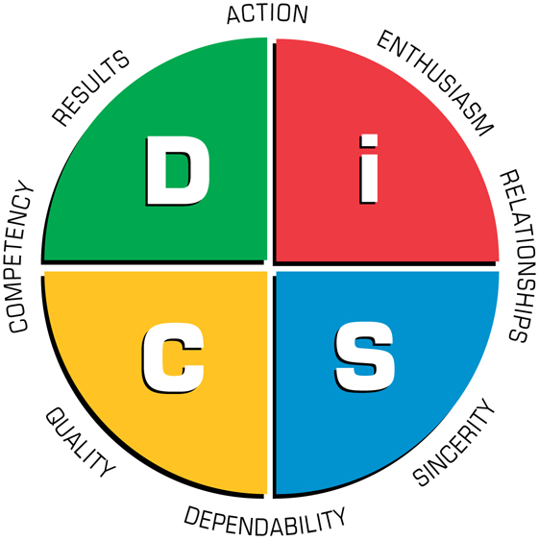

- D – Stands for Dominance.
  - People with this style are results oriented, like to challenge the status quo and take action.

- I – Stands for Influence.
  - People with this style are enthusiastic. They enjoy collaboration as well as taking action.

- S – Stands for Steadiness.
  - People with an S style tend to support those around them. They thrive on collaboration as well as a stable environment.

- C – Stands for Contentiousness
  - (I know, it’s a tough one, eh?). I had to practice saying that one several times before facilitating my first DiSC workshop! Anyways, the C style strives for accuracy. Although the like a challenge, they appreciate the need for stability.

